Chemainus Secondary School has an incredible opportunity to have a covered outdoor learning space built on our campus to be used by all learners throughout the school year.
Funds have been acquired from a one-time grant from the government, to promote the creation of outdoor learning spaces, but the timeline is VERY tight.
In the time since the grant application and receiving of funds, we are $5000 short to get this project happening, due to the increased costs of building materials and labour. We have to assure that we have the funds for this project before the end of May, or risk losing the grant money entirely.
We are asking for your help to raise the needed funds and are hopeful we can count on the support of our community.
The vision for our Outdoor Learning Centre consists of a covered structure and amphitheatre, along with an expansion and revitalization of our garden space.
It will occur in 3 phases:
Phase 1 will be the building of the covered structure.
Phase 2 will be the construction of a natural rock amphitheater up the slope in front of the structure.
Phase 3 will be the expansion/revitalization of our current garden space to include new fencing, gate, irrigation and landscaping to tie the whole project together.
This project is so important, as we know that regular time spent outdoors contributes to better mental health and happiness, regardless of age, and research at the K-12 level indicates that outdoor experiences lead to higher student engagement and test scores, and notably, fewer violent incidents. The creation and consistent use of outdoor environments must be a priority in K-12 design to foster students’ overall wellbeing.
This space will also be a benefit to the broader community as it can be used by the general public during non-school hours, just as our school track does now.
During this time, our PAC has limited fundraising opportunities and working within this unexpected deadline makes it difficult to raise the funds ourselves. The government gaming grant funds our PAC receives each year have strict guidelines, and they must be used for student extracurricular support only.
Tax receipts can be issued by request of the donor, for a minimum donation of $100.
Speak to someone in our front office at 250-246-4711 to arrange your donation or email chss@sd79.bc.ca
We greatly appreciate your support,
Alana Starkie
CHSS PAC Chair
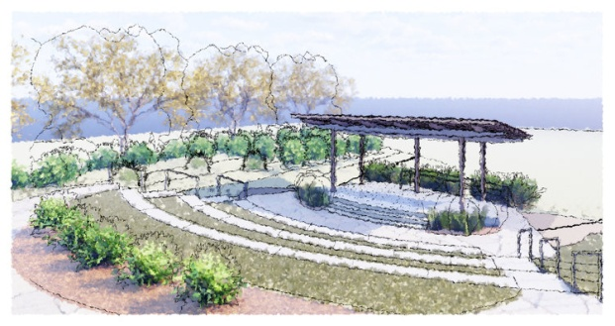
This photo is an example of the envisioned space.

