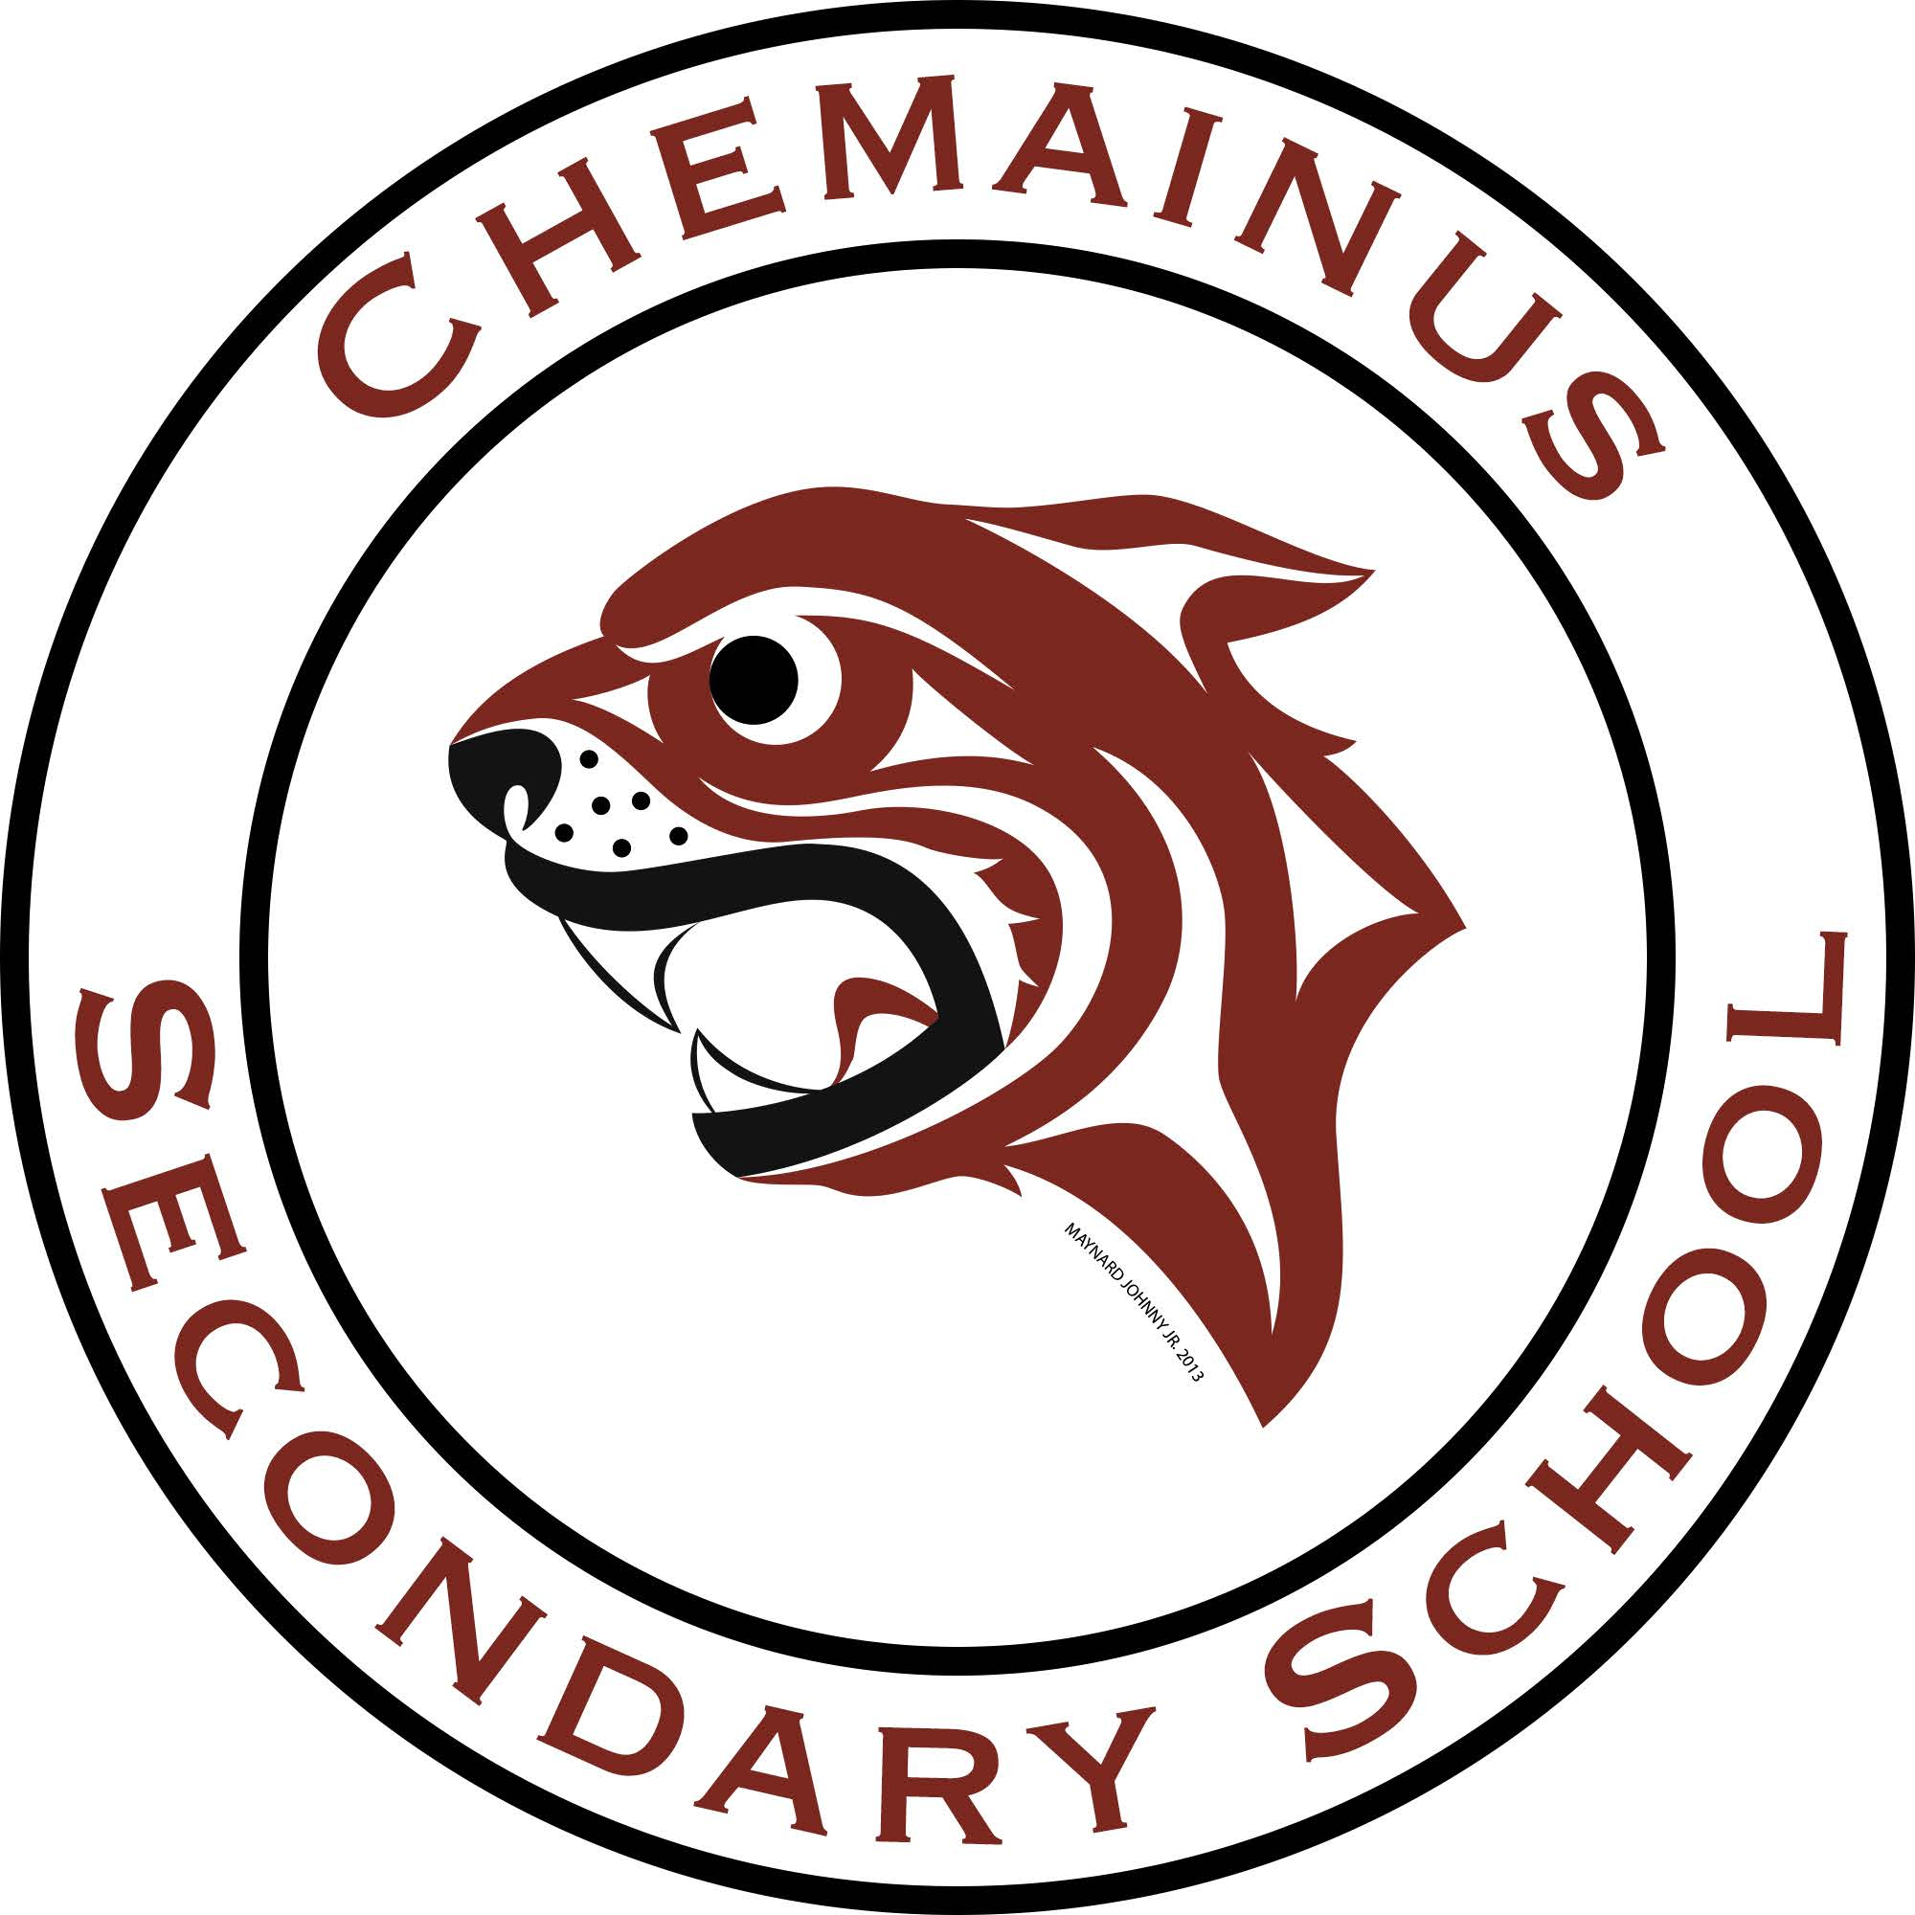

**GRADE 7 & 8**

**Program Description**

**2023 – 2024**

### **CHEMAINUS SECONDARY SCHOOL INFORMATION**

**Principal – Mr. J. Doyle jdoyle@sd79.bc.ca**

**Vice-Principal - Ms. R. LaForge – rlaforge@sd79.bc.ca**

**Counsellor - Mr. G. Culbertson (A – L) gculbert@sd79.bc.ca**

**Counsellor - Mrs. B. Stoochnoff (M – Z) bstoochn@sd79.bc.ca**

**Counselling Secretary –chsscounsellingsecretary@sd79.bc.ca**

**9947 Daniel Street, Chemainus, BC V0R 1K1**

**250-246-4711**

**email:** [**chss@sd79.bc.ca**](mailto:chss@sd79.bc.ca)

**web: chss.sd79.bc.ca**

**FACEBOOK & APP: ChemainusSecondarySchool**

**Code of Conduct – at a glance**

Do I understand the expectations at Chemainus Secondary?

* Yes! I am a **responsible** learner.
* Yes! I am a **respectful** member of the class and community. ***staff:counsellingsec:Desktop:Chemainus cougar logo-3-1.pdf***
* Yes! I am striving for excellence.
* Yes! I understand that all choices have consequences.
* Yes! I am responsible with how I use and treat technology.
* Yes! …. I am becoming an independent adult.

**\*School and District Expectations at all times**\*

**Welcome to Chemainus Secondary!**

**Grade 7/8 Middle Years Program**

**Moving from elementary to secondary is a big change in a students’ life. This programming guide is intended to provide information which students and parents should find helpful in making the transition to their new school.**

We recognize that grade 7 and 8 students are not developmentally or socially ready for secondary school, so we have purposely designed our grade 7 and 8 program as a middle years’ model.

**What is a middle years’ model?**

•The focus is on the uniqueness of development of young adolescents as they shift from elementary to secondary school

• Students are grouped in cohorts that stay together for the year

• Teaching teams share the same students for the year and share the academic areas

• Teacher advisory time for community building, learning support & extension

• Exploratory cycle to give a ‘taste’ of a variety of elective options

**What are exploratories?**

* An opportunity for students to have experiences in a variety of elective areas as a “taster” for future years when they will choose their electives for the semester.
* Exploratory classes (tentative):
  + Dance
  + Art
  + Drama
  + Foods
  + Textiles
  + Metalwork
  + Woodwork
  + Music
  + French/*Hul’quim’num (TBD)*
  + Computers
  + Robotics

**Get involved!**

* We encourage all students to get involved in their school, through athletics, clubs, leadership activities, intramurals, etc.

**COMMUNICATION BETWEEN HOME AND SCHOOL**

Communication between home and school is key to the partnership necessary for a student’s success in school. The administration, counsellors and teachers welcome parent calls and want to address any questions and concerns as they arise. Parents are encouraged to take an active part in the Chemainus Secondary School Parent Advisory Council (PAC). We regularly issue a monthly school newsletter ***REFLECTIONS***, which outlines school news, activities, and provides updated calendars. We also have a school website at chss.sd79.bc.ca, Facebook @ChemainusSecondarySchool and Chemainus Secondary APP.

Teachers and Administrators rely on e-mail and phone as a primary means of communication with parents and guardians. Teacher updates of student progress, newsletters, administrative bulletins and PAC information are frequently sent to parents in an e-mail format. **Please ensure all contact e-mail addresses and phone numbers are current. Reach out to our counselling office if updates are needed: chsscounsellingseceretary@sd79.bc.ca**

**STUDENT FEES**

All students are required to pay a $25.00 student fee every year. The fee is used to pay for items such as: agenda books, spirit day activities, school barbeques and guest speakers. Register online at [https://sd79.schoolcashonline.com](https://sd79.schoolcashonline.com/)

**SUPPORT SERVICES**

Support services are available to students experiencing difficulties. These may be learning challenges, emotional or social problems, or organizational issues. Areas of support available at Chemainus Secondary School include Counsellors, Peer Tutors, Learning Assistance and Teacher Advisors

**COURSE DESCRIPTIONS**

**ENGLISH 7/8**

The English 7/8 curriculum is designed to empower students by providing them with strong communication skills, an understanding and appreciation of language and literature, and the capacity to engage fully as literate and responsible citizens in a digital age. Students will use oral, written, visual and digital texts to access information. Students will learn about strategies, processes, writing structures and conventions. Students are guided in their learning to think critically, creatively, and reflectively; to construct a sense of personal and cultural identity; and to be respectful of a range of perspectives and worldviews.

**SOCIAL STUDIES 7/8**

The Big ideas for SS 7/8 are: contacts and conflicts between peoples stimulated significant cultural, social, political change; human and environmental factors shape changes in population and living standards; exploration, expansion, and colonization had varying consequences for different groups and hanging ideas about the world created tension between people wanting to adopt new ideas and those wanting to preserve established traditions. The time period to be discovered is 7th Century to 1750. Students will conduct inquiry and research during the course. Written assignments and tests will also be forms of evaluation.

**MATHEMATICS 7/8**

Mathematics 7/8 emphasizes numeracy to help us see patterns, communicate ideas and solve problems. We will apply mathematics to inquiry questions which will enable us to draw conclusions and make predications. Students will analyze, reason, and make connections when solving problems. Numeracy content includes percentiles, square roots, proportions, fractions, equations, surface area & volume, and financial literacy. A scientific calculator is required.

**SCIENCE 7/8**

Science 7/8 requires students to demonstrate intellectual curiosity about a scientific topic or problem of personal interest. Students will make observations, work collaboratively, draw conclusions and communicate ideas. Scientific content includes cells, kinetic theory, theory of the atom, energy and plate tectonics. A scientific calculator is required.

**FRENCH 7/8**

Emphasis will be on giving the student a positive experience with the French language, keeping in mind that not all students may choose to carry on with French in their high school career. Classroom work will consist of written and oral (spoken) work. Some writing activities must be completed at home.

There will be participation in simple spoken activities and skits that will be presented to the class. Several countries where French is spoken are introduced. French culture is presented as far as it is relevant to the age levels of the students.

**CAREER EDUCATION 7/8**

The Career Education curriculum supports students in the process of becoming successful, educated citizens by providing them with opportunities to explore a variety of careers and options for their future. Career Education helps students to discover a bridge between classroom learning and workplace and post-secondary realities and is intended to make their learning meaningful and relevant. In Grades 8, students explore concepts such as identity, leadership, personal planning, and transferable skills. As students build on the foundation developed from their experiences, they begin to explore in greater depth their skills and passions and begin to determine possible routes to their goals.

**PHYSICAL AND HEALTH EDUCATION 7/8**

This course is designed to provide the knowledge and skills necessary for students to successfully participate in different physical activities and make to decisions that will lead to a healthy lifestyle. Students develop skills in the areas of physical literacy, healthy and active living, social and community health, and mental well-being. The knowledge component includes such topics as fundamental movement skills and strategies, training principles, sources of health information, signs and symptoms of stress, anxiety and depression, nutrition, and healthy relationships.

All PE students are required to have PE strip: t-shirt, short/track pants, running shoes and a towel.

**EXPLORATORIES**

Students are introduced to a variety of exploratory courses to expose them to different options they can pursue as they move into higher grades. All students rotate through a number of short courses. These courses may include the following:

*Home Economics 🡺 Robotics 🡺 Metalwork 🡺 Woodwork 🡺 Art 🡺 Dance 🡺 Drama 🡺Computers🡺French*

The only choice for grade 8 is music. If your son/daughter chooses music, which runs every other day, their exposure to our exploratory courses is shortened in the number of actual classes.

**ROBOTICS 7/8**

In this course, students learn about ‘Design Thinking’ and how it can be applied to solve real life problems. Students learn about the history of robotics and real-world applications. We will look at building robots and how they work. Students learn coding and use their skills to program robots.

**WOODWORK 7/8**

Woodwork is an introduction to working with wood featuring the safe use of hand and power tools. Students make three projects, which give them samples of what can be designed and constructed in the woodshop

**HOME ECONOMICS 7/8**

**FOODS 7/8**

Students are introduced to basic cooking skills. You will learn basic cooking techniques like how to measure ingredients, how to follow a recipe, and how to use basic kitchen equipment and utensils while making a variety of quick dishes.

**TEXTILES 7/8**

Students will explore the world of textiles. They will get the opportunity to work with different textile projects and textile art techniques. Topics may include weaving, sewing, fashion, felting, braiding/knotting, etc.

**COMPUTERS AND COMMUNICATIONS DEVICES 7/8**

In this course, students learn about how to use different software programs and about the digital world. We will talk about how the internet works and computer programming. Students will learn how to type properly, create word processing documents, digital presentations, spreadsheets, photoshop files, and animations.

**BAND 7/8**

Band 7/8 is a performance-based study of instrumental music through the traditional concert band forms. This may be an introductory course for students with no band background or an advanced course for those who have taken band before. Students who participate in band will have a hybrid exploratory experience.

**DANCE 7/8**

This course explores numerous genres of dance. Students will develop an understanding of the cultural significance as well as the basic movements of the dances covered.

**PERFORMING ARTS 7/8**

This course explores drama activities and improv. Students will develop an understanding of performing arts concepts through participation in musical experiences that involve listening, moving, creating, and performing, as well as dramatic skills involving body, voice, imagination, trust and in-role activities.

**ART 7/8**

In this course students will become familiar with the Elements and Principles of art. They will incorporate these concepts to produce a variety of projects that will encourage critical thinking, personal and social responsibility and communication.

**METAL WORK 7/8**

Metalwork is a project-oriented course in which students will be introduced to metalworking and shop safety. Safe use of hand tolls will be emphasized.